North Adelaide Heritage Group
North Adelaide Heritage Group
Office: 109 Glen Osmond Road
Eastwood South Australia 5063
ABN 44 748 172 502
A.C.N. 062 352 550

Phone: 61 8 8272 1355
Fax: 61 8 8272 1355
Email: sales@adelaideheritage.com
www.adelaideheritage.com

A fabulous memento of your occasion at the Fire Station Inn
1940 – Ford V8
Fire Truck Pedal Car
Features 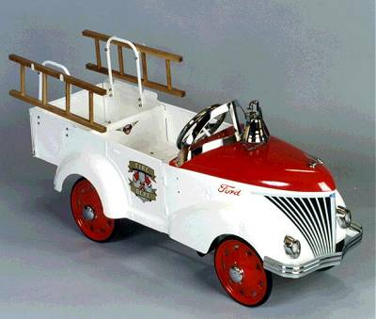
- Electric lights
- Replica V8 engine
- Opening bonnet
- Bell with fire mans hat on top
- Artillery wheels
- Chromed bonnet ornament
- Chromed windshield
- Oak wood ladders
- Chromed plated bumpers and hub caps
- Heavy gauge metal
- Adjustable pedals.
- Startling Red and white Paintwork
SPECIFICATIONS:
These old fashioned pedal cars are designed exclusively for children aged two to six years and are a parents and collectors dream. The cars are all metal, 18 gauge steel, constructed for durability. We use lead free powder coat for extended wear. Solid rubber tyres for increased traction, five position adjustable pedal drive train will grow with the child. The sealed bearing wheel mechanism ensures a smooth ride & long life. Product licensed to original manufacturer. Due to Rodney’s association as a long time antique dealer we have been able to source this Fire Engine directly from the Manufacturer. We can also arrange transport economically to your home. “Don't just give them a toy, give them an Heirloom to remember all of their life” says Rodney Twiss. Call Rodney for stock details and price. Ph 61 8 8272 1355

